**INDIVIDUAL ASSIGNMENT**

**BANKING SYSTEM**

**Task 1: Database Design:**

1. Create the database named "HMBank"

* CREATE DATABASE HMBank;

1. Define the schema for the Customers, Accounts, and Transactions tables based on the provided schema.

* Customers Table

customer_id (Primary Key)

first_name

last_name

DOB

email

phone_number

address

Accounts Table

account_id (Primary Key)

customer_id (Foreign Key)

account_type

balance

Transactions Table

transaction_id (Primary Key)

account_id (Foreign Key)

transaction_type

amount

transaction_date

1. Create an ERD (Entity Relationship Diagram) for the database.

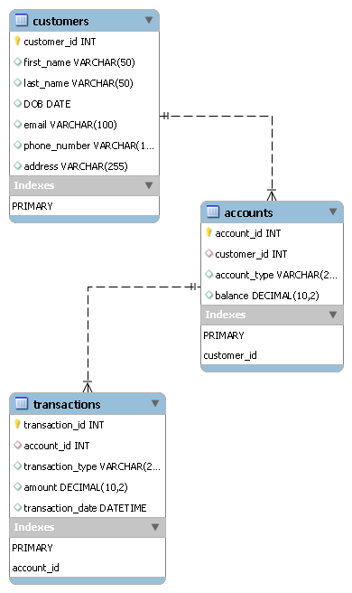

1. Create appropriate Primary Key and Foreign Key constraints for referential integrity.

Customers

customer_id is the Primary Key.

Accounts

account_id is the Primary Key.

customer_id is a Foreign Key referencing Customers(customer_id).

Transactions

transaction_id is the Primary Key.

account_id is a Foreign Key referencing Accounts(account_id).

1. Write SQL scripts to create the mentioned tables with appropriate data types, constraints, and relationships.

• Customers

• Accounts

• Transactions

Use HMBank;

CREATE TABLE Customers (

customer_id INT PRIMARY KEY,

first_name VARCHAR (50) NOT NULL,

last_name VARCHAR (50) NOT NULL,

DOB DATE NOT NULL,

email VARCHAR (100),

phone_number VARCHAR (15) NOT NULL,

address VARCHAR (255)

);

CREATE TABLE Accounts (

account_id INT PRIMARY KEY,

customer_id INT NOT NULL,

account_type VARCHAR (20) NOT NULL,

balance DECIMAL (10, 2) NOT NULL DEFAULT 0.00,

FOREIGN KEY (customer_id) REFERENCES Customers(customer_id)

);

CREATE TABLE Transactions (

transaction_id INT PRIMARY KEY,

account_id INT NOT NULL,

transaction_type VARCHAR (20) NOT NULL,

amount DECIMAL (10, 2) NOT NULL,

transaction_date DATETIME NOT NULL,

FOREIGN KEY (account_id) REFERENCES Accounts(account_id)

);

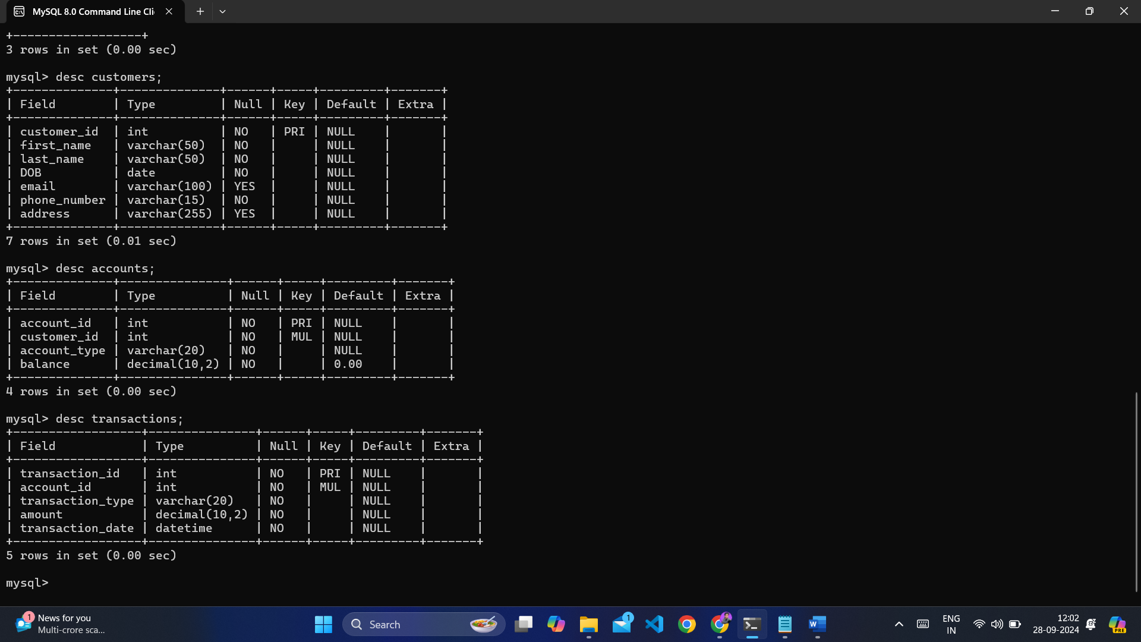

**Task 2: Select, Where, Between, AND, LIKE:**

1. Insert at least 10 sample records into each of the following tables.

• Customers

• Accounts

• Transactions

INSERT INTO Customers (customer_id, first_name, last_name, DOB, email, phone_number, address) VALUES

(1, 'Alzeb', 'Khan', '2001-06-24', 'alzebkhan@gmail.com', '9815515165', 'Jhansi'),

(2, 'Kartikey', 'Rajpoot', '2000-08-20', 'kartikey@gmail.com', '7054885265', 'Mumbai'),

(3, 'Aditya', 'Singh', '1999-12-05', 'aditya.singh@gmail.com', '9776543210', 'Bangalore'),

(4, 'Anaya', 'Kaur', '1980-02-15', 'anaya.kaur@gmail.com', '9765432109', 'Chennai'),

(5, 'Diya', 'Patel', '1995-03-25', 'diya.patel@gmail.com', '9654321098', 'Hyderabad'),

(6, 'Rohan', 'Mehta', '1988-07-10', 'rohan.mehta@gmail.com', '9543210987', 'Ahmedabad'),

(7, 'Sneha', 'Singh', '1992-11-30', 'sneha.singh@gmail.com', '9432109876', 'Pune'),

(8, 'Karan', 'Sharma', '1983-04-22', 'karan.sharma@gmail.com', '9321098765', 'Jaipur'),

(9, 'Pooja', 'Verma', '1999-01-01', 'pooja.verma@gmail.com', '9210987654', 'Lucknow'),

(10, 'Rahul', 'Chowdhary', '1996-09-12', 'rahul.chowdhary@gmail.com', '9109876543', 'Kolkata');

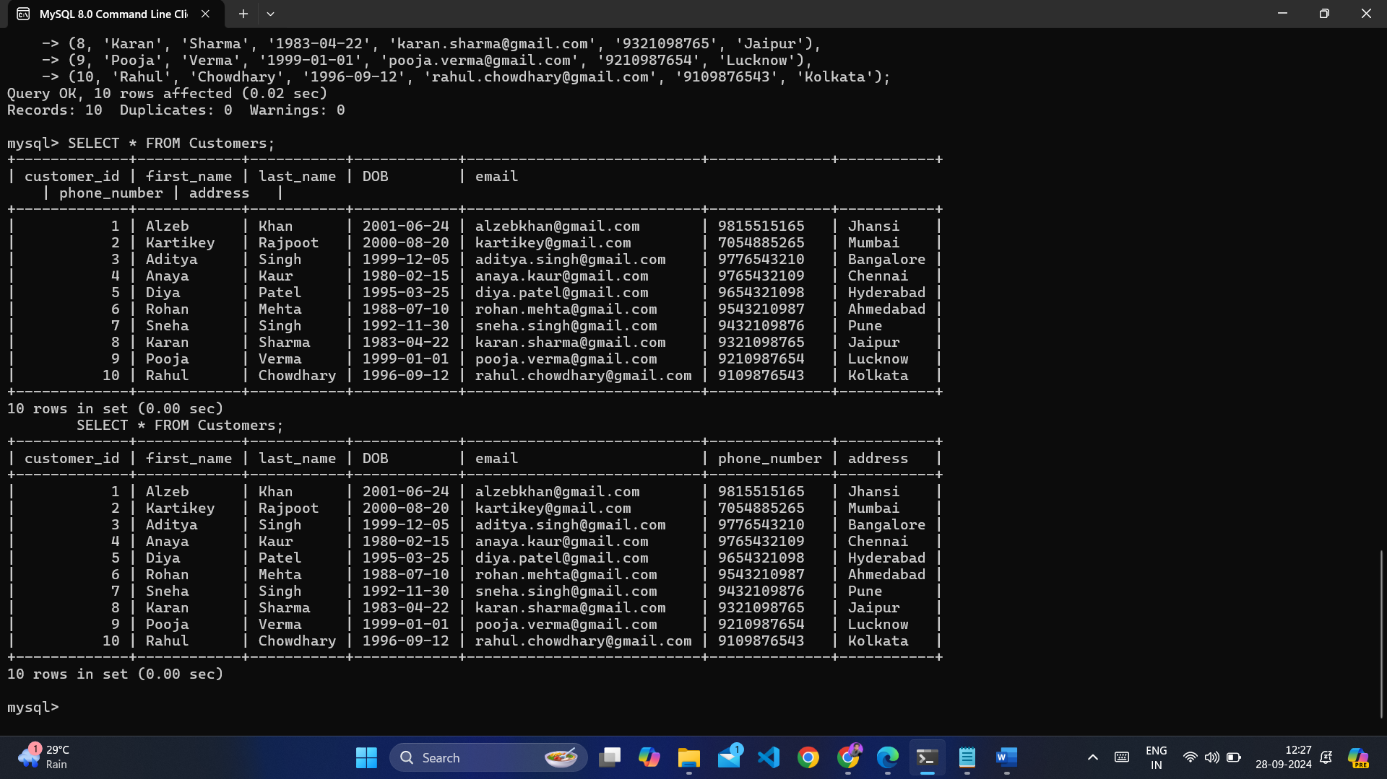

INSERT INTO Accounts (account_id, customer_id, account_type, balance) VALUES

(101, 1, 'savings', 1500.00),

(102, 2, 'current', 2500.00),

(103, 3, 'savings', 0.00),

(104, 4, 'zero_balance', 0.00),

(105, 5, 'savings', 300.00),

(106, 6, 'current', 1200.00),

(107, 7, 'savings', 800.00),

(108, 8, 'current', 1500.00),

(109, 9, 'savings', 500.00),

(110, 10, 'zero_balance', 0.00);

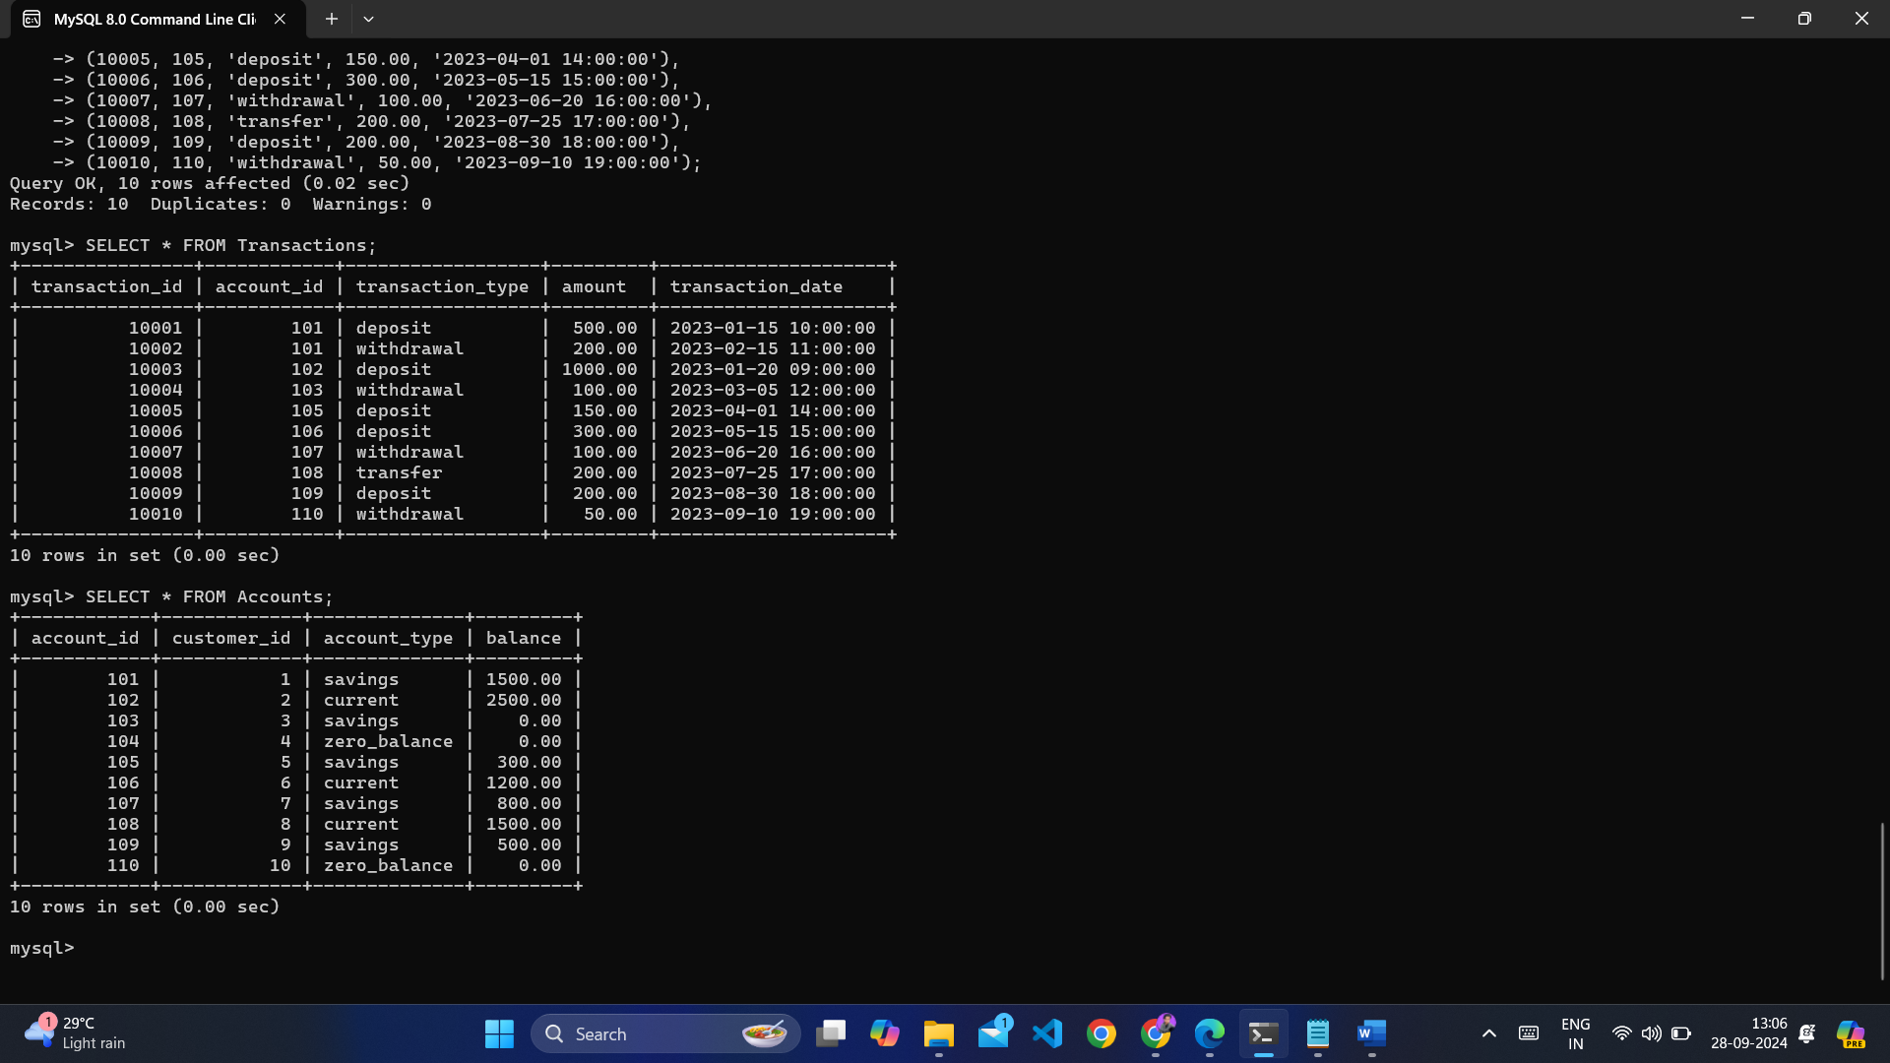

.

INSERT INTO Transactions (transaction_id, account_id, transaction_type, amount, transaction_date) VALUES

(10001, 101, 'deposit', 500.00, '2023-01-15 10:00:00'),

(10002, 101, 'withdrawal', 200.00, '2023-02-15 11:00:00'),

(10003, 102, 'deposit', 1000.00, '2023-01-20 09:00:00'),

(10004, 103, 'withdrawal', 100.00, '2023-03-05 12:00:00'),

(10005, 105, 'deposit', 150.00, '2023-04-01 14:00:00'),

(10006, 106, 'deposit', 300.00, '2023-05-15 15:00:00'),

(10007, 107, 'withdrawal', 100.00, '2023-06-20 16:00:00'),

(10008, 108, 'transfer', 200.00, '2023-07-25 17:00:00'),

(10009, 109, 'deposit', 200.00, '2023-08-30 18:00:00'),

(10010, 110, 'withdrawal', 50.00, '2023-09-10 19:00:00');

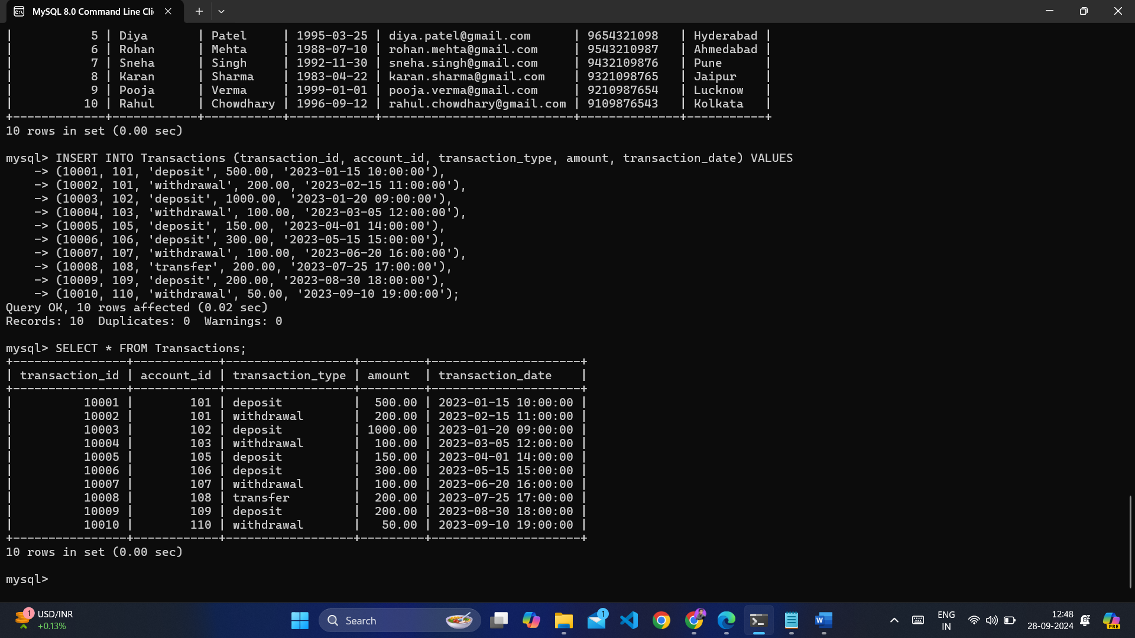

1. Write SQL queries for the following tasks:
2. Write a SQL query to retrieve the name, account type and email of all customers.

SELECT first_name, last_name, account_type, email

FROM Customers, Accounts

WHERE Customers.customer_id = Accounts.customer_id;

1. Write a SQL query to list all transaction corresponding customer.

SELECT first_name, last_name, transaction_type, amount, transaction_date

FROM Customers, Accounts, Transactions

WHERE Customers.customer_id = Accounts.customer_id

AND Accounts.account_id = Transactions.account_id;

1. Write a SQL query to increase the balance of a specific account by a certain amount.

UPDATE Accounts

SET balance = balance + 100.00

WHERE account_id = 101;

1. Write a SQL query to Combine first and last names of customers as a full_name.

SELECT CONCAT (first_name, ' ', last_name) AS full_name

FROM Customers;

1. Write a SQL query to remove accounts with a balance of zero where the account type is savings.

DELETE FROM Accounts

WHERE balance = 0 AND account_type = 'savings';

1. Write a SQL query to Find customers living in a specific city.

SELECT first_name, last_name, address FROM Customers

WHERE address LIKE '%Jhansi%';

1. Write a SQL query to Get the account balance for a specific account.

SELECT account_id, balance FROM Accounts

WHERE account_id = 101;

1. Write a SQL query to List all current accounts with a balance greater than $1,000.

SELECT * FROM Accounts

WHERE account_type = 'current' AND balance > 1000;

1. Write a SQL query to Retrieve all transactions for a specific account.

SELECT * FROM Transactions

WHERE account_id = 101;

1. Write a SQL query to Calculate the interest accrued on savings accounts based on a given interest rate.

SELECT account_id, (balance * 0.03) AS interest

FROM Accounts WHERE account_type = 'savings';

1. Write a SQL query to Identify accounts where the balance is less than a specified overdraft limit.

SELECT * FROM Accounts

WHERE balance < -100.00;

1. Write a SQL query to Find customers not living in a specific city.

SELECT * FROM Customers

WHERE address NOT LIKE '%Jhansi%';

**Task 3: Aggregate functions, Having, Order By, GroupBy and Joins:**

1. Write a SQL query to Find the average account balance for all customers.

SELECT AVG(balance) AS average_balance

FROM Accounts;

1. Write a SQL query to Retrieve the top 10 highest account balances.

SELECT account_id, balance FROM Accounts

ORDER BY balance DESC LIMIT 10;

1. Write a SQL query to Calculate Total Deposits for All Customers in specific date.

SELECT SUM(amount) AS total_deposits FROM Transactions

WHERE transaction_type = 'deposit' AND DATE(transaction_date) = '2023-01-15';

1. Write a SQL query to Find the Oldest and Newest Customers.

SELECT MIN(DOB) AS oldest_customer, MAX(DOB) AS newest_customer FROM Customers;

1. Write a SQL query to Retrieve transaction details along with the account type.

SELECT t.transaction_id, t.transaction_type, t.amount, t.transaction_date, a.account_type

FROM Transactions t

JOIN Accounts a ON t.account_id = a.account_id;

1. Write a SQL query to Get a list of customers along with their account details.

SELECT c.first_name, c.last_name, a.account_id, a.account_type, a.balance

FROM Customers c

JOIN Accounts a ON c.customer_id = a.customer_id;

1. Write a SQL query to Retrieve transaction details along with customer information for a specific account.

SELECT t.transaction_id, t.transaction_type, t.amount, t.transaction_date, c.first_name, c.last_name

FROM Transactions t

JOIN Accounts a ON t.account_id = a.account_id

JOIN Customers c ON a.customer_id = c.customer_id

WHERE a.account_id = 101;

1. Write a SQL query to Identify customers who have more than one account.

SELECT c.customer_id, c.first_name, c.last_name

FROM Customers c

JOIN Accounts a ON c.customer_id = a.customer_id

GROUP BY c.customer_id

HAVING COUNT(a.account_id) > 1;

1. Write a SQL query to Calculate the difference in transaction amounts between deposits and withdrawals.

SELECT

(SELECT SUM(amount) FROM Transactions WHERE transaction_type = 'deposit') -

(SELECT SUM(amount) FROM Transactions WHERE transaction_type = 'withdrawal') AS difference;

1. Write a SQL query to Calculate the average daily balance for each account over a specified period.

?

1. Calculate the total balance for each account type.

SELECT account_type, SUM (balance) AS total_balance

FROM Accounts

GROUP BY account_type;

1. Identify accounts with the highest number of transactions order by descending order.

SELECT a.account_id, COUNT(t.transaction_id) AS transaction_count

FROM Accounts a

JOIN Transactions t ON a.account_id = t.account_id

GROUP BY a.account_id

ORDER BY transaction_count DESC;

1. List customers with high aggregate account balances, along with their account types.

SELECT c.customer_id, c.first_name, c.last_name, a.account_type, SUM(a.balance) AS total_balance

FROM Customers c

JOIN Accounts a ON c.customer_id = a.customer_id

GROUP BY c.customer_id, c.first_name, c.last_name, a.account_type

HAVING total_balance > 1000;

1. Identify and list duplicate transactions based on transaction amount, date, and account.

SELECT t.account_id, t.amount, t.transaction_date, COUNT(*) AS transaction_count

FROM Transactions t

GROUP BY t.account_id, t.amount, t.transaction_date

HAVING transaction_count > 1

ORDER BY t.account_id, t.transaction_date;

**Tasks 4: Subquery and its type:**

1. Retrieve the customer(s) with the highest account balance.

2. Calculate the average account balance for customers who have more than one account.

3. Retrieve accounts with transactions whose amounts exceed the average transaction amount.

4. Identify customers who have no recorded transactions.

5. Calculate the total balance of accounts with no recorded transactions.

6. Retrieve transactions for accounts with the lowest balance.

7. Identify customers who have accounts of multiple types.

8. Calculate the percentage of each account type out of the total number of accounts.

9. Retrieve all transactions for a customer with a given customer_id.

10. Calculate the total balance for each account type, including a subquery within the SELECT clause.